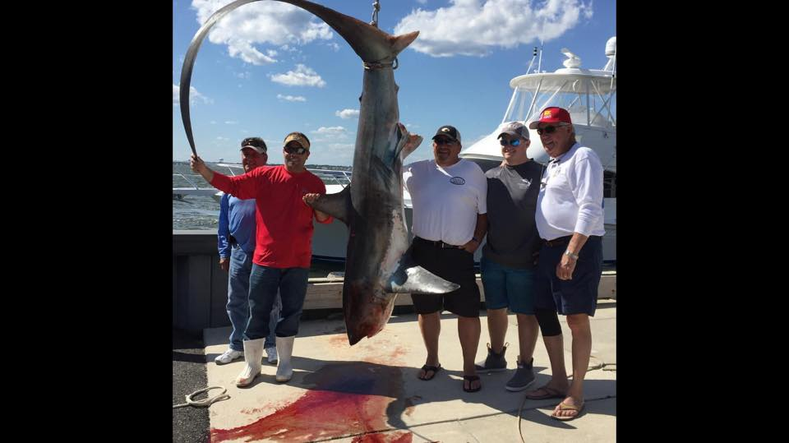

OCMTC 2023 SHARK/BLUEFIN TOURNAMENT
SATURDAY JUNE 10TH
-FISHING TIME: 6:00AM TO 3:00PM
-BOATS MAY LEAVE GE INLET ANY TIME AFTER 12AM
****NO CAPTAINS MEETING FOR THIS EVENT****
-ALL BOATS MUST REGISTER BY CALLING 1-855-GET TUNA
-ALL CURRENT HMS AND IGFA RULES APPLY FOR SHARK AND TUNA
-MINIMUM WEIGHT FOR CAPTURED SHARKS IS 100LBS (1 CAPTURED SHARK PER BOAT)
-CAPTURED THRESHER IS WORTH 1 POINT/LB (99LB THRESHER=0 POINTS)
-EACH RELEASED SHARK 10 POINTS (TIES SETTLED BY TIME OF RELEASE)
-REPORT ALL SHARK RELEASES TO ANOTHER OCMTC BOAT AT TIME OF RELEASE.
-10 SHARKS MAXIMUM RELEASED QUALIFY FOR POINTS
-MINIMUM WEIGHT FOR BLUEFIN IS 40LBS (1 POINT/LB) NO POINTS FOR TUNA RELEASES.
-HMS REGULATIONS APPLY FOR TUNA MINIMUM/MAXIMUMS
-GIANT BLUEFIN ARE NOT ALLOWED IN THIS TOURNAMENT
-BOATS MAY FISH FOR BLUEFIN AND SHARK AND QUALIFY FOR POINTS IN BOTH CATEGORIES
-SPREADER BARS ALLOWED, HARPOONS MAY BE USED, BANG STICK OR GUNS ALLOWED FOR SHARK AFTER WIRING. CIRCLE HOOKS REQUIRED ON ALL NATURAL BAITS.
WEIGH IN AT OCYC- 4:00-7:00PM
***ALL RELEASE SLIPS TURNED IN TO WEIGH DOCK BY 7PM***
SHARK RELEASE FORM
SPECIES TIME OF RELEASE BOAT REPORTED TO
1___________________________________________________
2___________________________________________________
3___________________________________________________
4___________________________________________________
5___________________________________________________
6___________________________________________________
7___________________________________________________
8___________________________________________________
9___________________________________________________
10__________________________________________________

PRIZES:
THRESHER: 1ST, 2ND, 3RD HEAVIEST
BOAT AWARD: 1ST, 2ND, 3RD TOTAL POINTS
BLUEFIN: 1ST, 2ND, 3RD HEAVIEST
JUNIORS: 1ST, 2ND, (MUST BE UNDER 16 AS OF 6/10/23)

